Rental Car Inbound Voice & Appointment Automation
GoHighLevel | Synthflow | Voice Agent | CRM | Appointment Booking | Email

Project Overview
Built an inbound voice and appointment automation system for Jack Yewman using GoHighLevel and Synthflow.
The system handles incoming customer calls, manages appointment bookings, updates contact records, and sends appointment confirmation emails automatically.
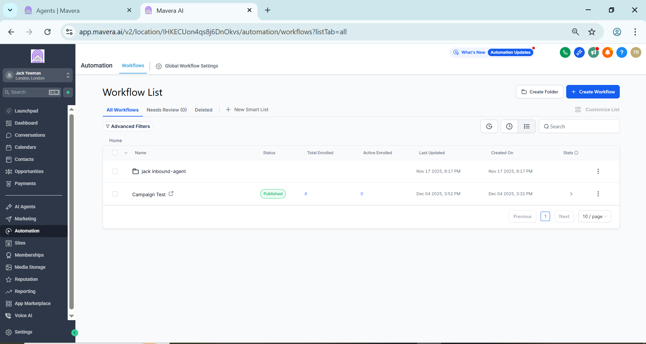
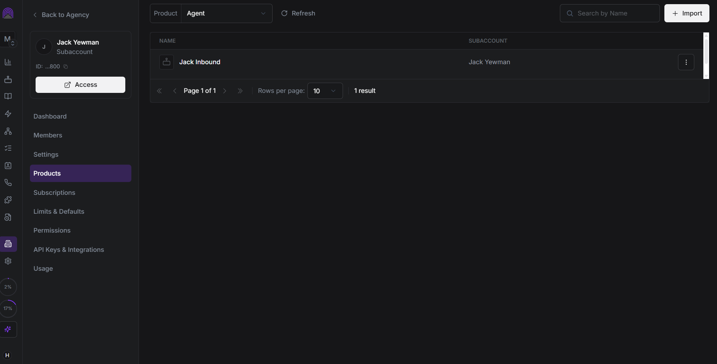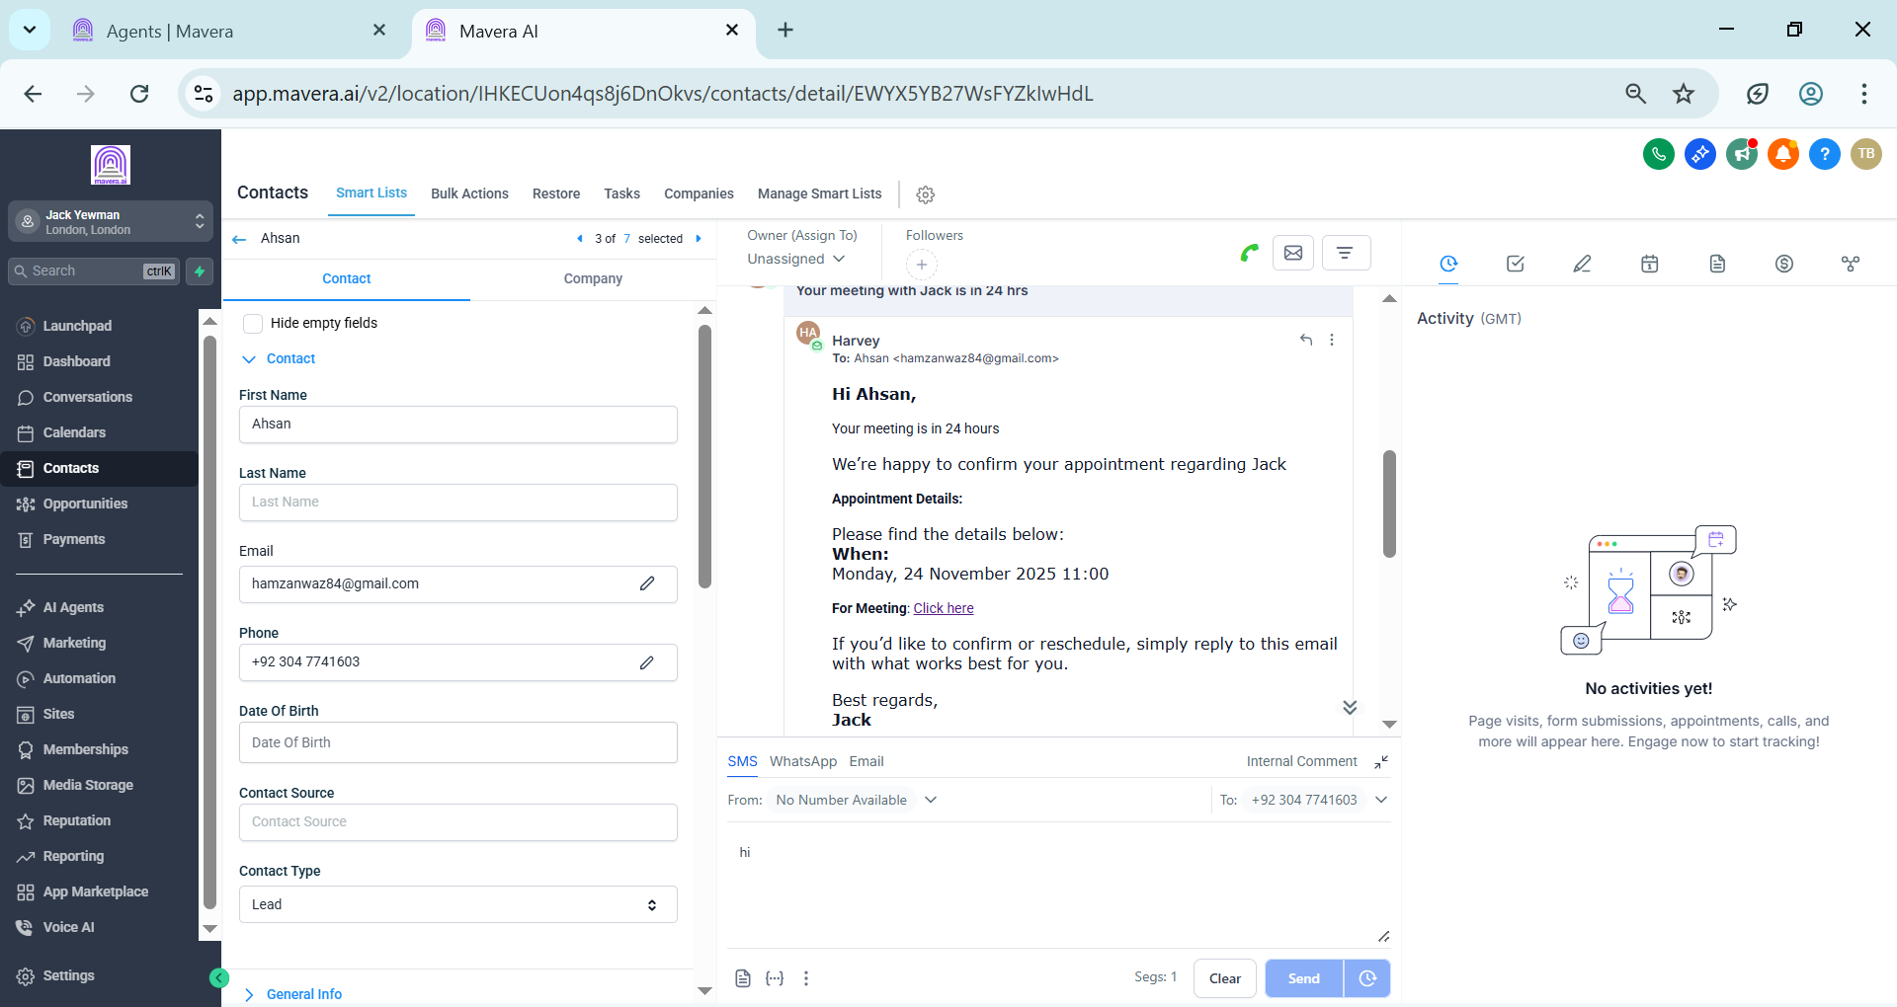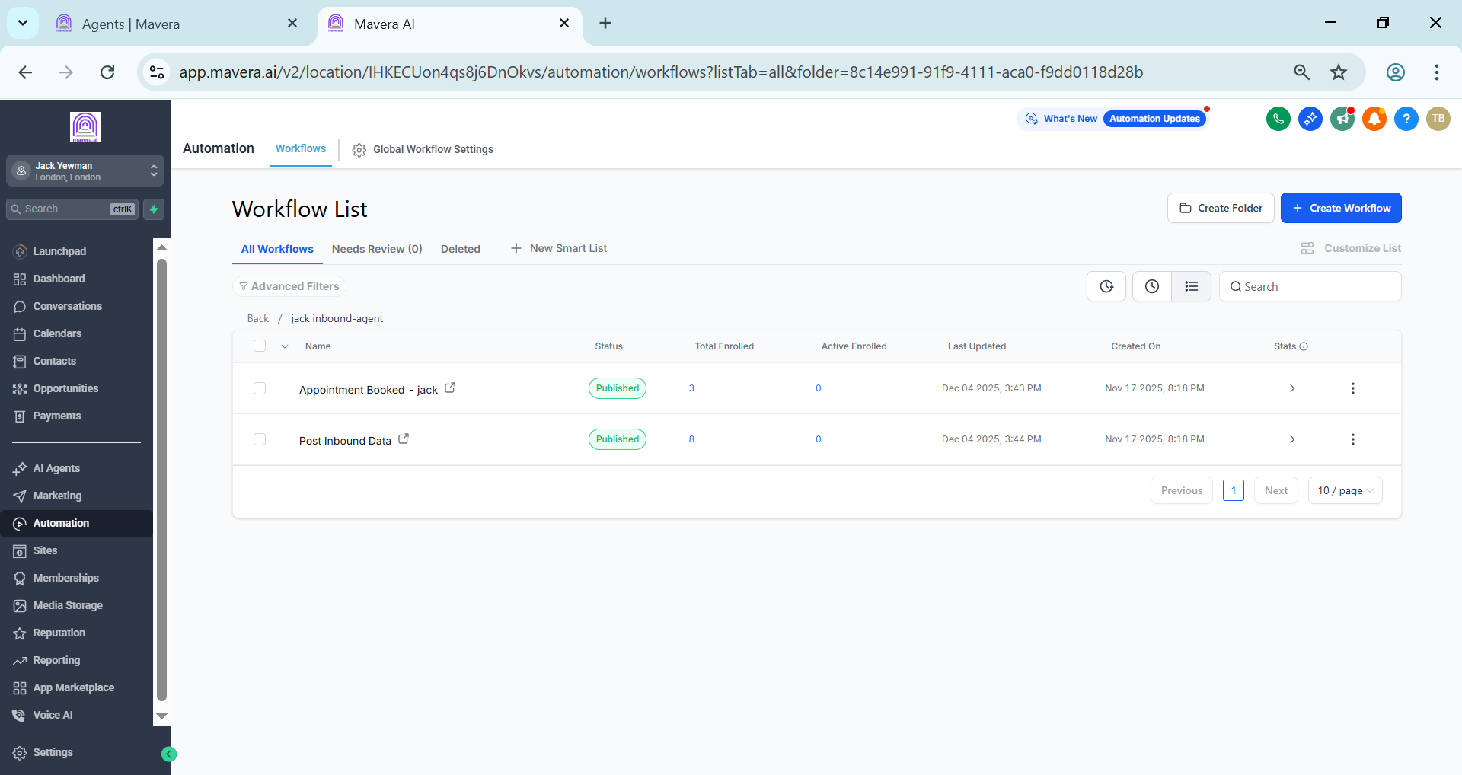

Voice Agent Setup
Configured a dedicated Jack Inbound voice agent in Synthflow for handling incoming calls.
The agent connects with the GoHighLevel subaccount and supports the appointment booking process.

GoHighLevel Workflows
The setup includes dedicated workflows for:
• Appointment Booked
• Post Inbound Data
• Inbound Agent
• Campaign handling
These workflows keep customer information and call outcomes organized inside the CRM.

Appointment Automation
When an appointment is booked, the system updates the contact record and triggers the required follow up process.
Appointment information is used to prepare the confirmation communication automatically.

Email Confirmation
The system sends appointment confirmation emails containing:
• Customer name
• Appointment date and time
• Meeting details
• Confirmation information
• Rescheduling instructions
The communication is recorded within the customer’s CRM record.

Technology
• GoHighLevel
• Synthflow
• Voice Agent
• CRM Workflows
• Appointment Booking
• Email Automation

Result
A complete inbound appointment system connecting voice calls, lead capture, CRM updates, appointment booking, and email confirmations in one workflow.
This reduces manual follow up work and keeps the entire appointment process organized inside GoHighLevel.

